Effaith Ffotodrydanol.

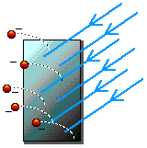
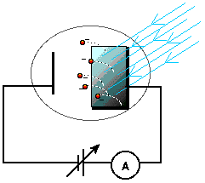

Yr effaith Yr arbrawf

E = h f
O arbrawf Einstein gellir dangos bod:
h f = EC + W neu EC = h f - W
h f = EC_{macs} + W_{o}
W_{o} = h f₀
KE_{max} = h f - W_{o}

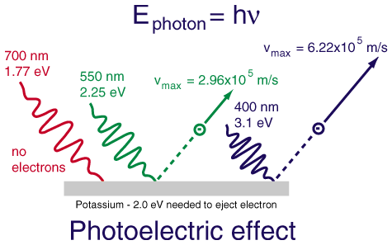

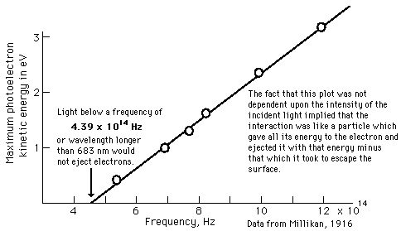

EC_{macs} = eV_{s}
EC_{macs} = hf – W

Felly: graddiant = h, W = croesdoriad yr echelin y

GWEFANNAU:
- Photoelectric effect.
- Hafaliad Einstein.
- Deualaeth tonnau-gronynnau.
- Hafaliad deBroglie.
- Data Robert Millikan (1915).
- Quantum Notes.

